Ideation Phase
Define the Problem Statements

Date | 01 October 2026
Team ID | SWTID-2026-2527
Project Name | Script-Controlled ACL – Restrict Record Access Based on Field Value
Maximum Marks | 2 Marks

Customer Problem Statement Template:
Create a problem statement to understand your customer's point of view. The Customer Problem Statement template helps you focus on what matters to create experiences people will love.
A well-articulated customer problem statement allows you and your team to find the ideal solution for the challenges your customers face. Throughout the process, you’ll also be able to empathize with your customers, which helps you better understand how they perceive your product or service.

Reference: https://miro.com/templates/customer-problem-statement/
Example:

Problem Statement (PS) | I am (Customer) | I’m trying to | But | Because | Which makes me feel
PS-1 | An EEE branch user | view institution records relevant to the EEE branch | I may see records from other branches if record-level controls are not configured | the table contains ECE, EEE and CSE records | concerned about privacy and uncertain about authorized records.
PS-2 | A ServiceNow administrator / lab implementer | allow the right users to read, create, edit and delete records | one broad permission cannot express different operation requirements | read, create, write and delete need separate ACL rules and roles | responsible for making the configuration secure and testable.

Project-specific interpretation
The project addresses record-level security in ServiceNow. The u_institution_details table stores records with Branch values ECE, EEE and CSE. The desired solution uses a scripted read ACL and separate create, write and delete ACLs so access depends on both role membership and the requested operation.

Design challenge
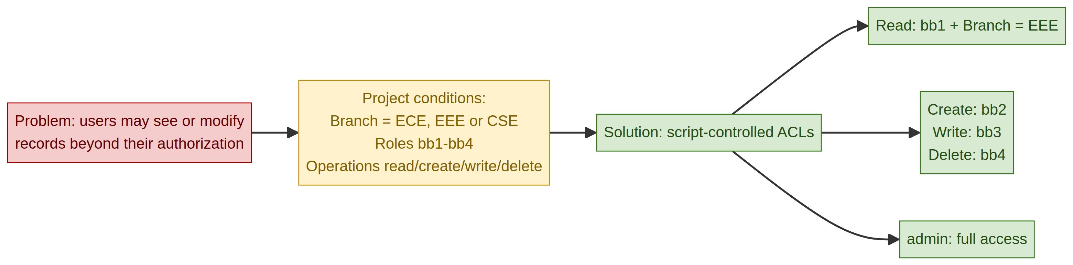
Project visual: mapping the access problem to the script-controlled ACL solution.
How might we configure script-controlled ACLs so that users access only the records and operations permitted by their roles and the Branch value, while administrators retain full access?
Visual note: The default example image from the original template was removed and replaced with a diagram based on the supplied ACL project.

